Acceleration of Exit Button

Make the system to be represented like a spring, such that the exit button returns to the point the cursor is as if the equilibrium position of simple harmonic motion. Slowing down the exit button will involve damping, which is a force that gradually reduces the oscillating motion of SHM. There are 3 types of damping:

1. Critical (hits the root) [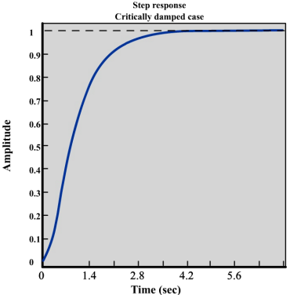](http://www.me.umn.edu/courses/me4231/labs/Lab7.pdf)
2. Under-damped (multiple real roots, i.e. oscillates before stopping at the root) [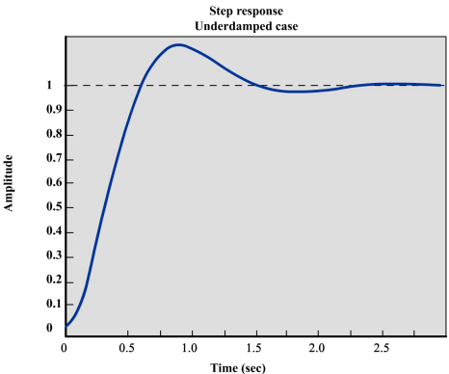](http://www.me.umn.edu/courses/me4231/labs/Lab7.pdf)
3. Over-damped (doesn’t hit the root) [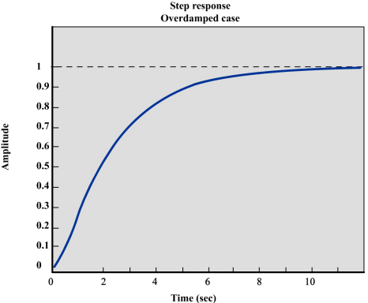](http://www.me.umn.edu/courses/me4231/labs/Lab7.pdf)

The program should hit the root, so use **critical damping** (i.e. ζ = 1). May want to include a case, where when it reaches the position, make velocity = 0. Need to decide natural frequency, ω­0.





Suggestion: get close to point, but also have small velocity



Discretize space?

Time march?

v0 = 500 pixels/s



I’ve decided to simplify this to a velocity calculation.

